What is generative AI?
Artificial Intelligence (AI) imitates human behavior by using machine learning to interact with the environment and execute tasks without explicit directions on what to output.
Generative AI describes a category of capabilities within AI that create original content.

Natural language generation
Generative AI applications take in natural language input and return appropriate responses in a variety of formats such as natural language, images, or code.

One popular example of such an application is ChatGPT, a chatbot created by OpenAI

Image generation
Some generative AI applications can interpret a natural language request and generate an appropriate image. For example, you might submit a request like "Create an image of an elephant eating a burger".

Code generation
Some generative AI applications are designed to help software developers write code. For example, you could submit a request like "Show me how to code a game of tic-tac-toe with Python" and generate the following response:

Large language models
Completed100 XP
- 10 minutes
Generative AI applications are powered by large language models (LLMs), which are a specialized type of machine learning model that you can use to perform natural language processing (NLP) tasks, including:
- Determining sentiment or otherwise classifying natural language text.
- Summarizing text.
- Comparing multiple text sources for semantic similarity.
- Generating new natural language.
While the mathematical principles behind these LLMs can be complex, a basic understanding of the architecture used to implement them can help you gain a conceptual understanding of how they work.

3.3.1 Generative Models for NLP
If you choose NLP as your area of focus, the following learning path will guide you to mastery of Generative Models for NLP.
- Discover the power of Large Language Models (LLMs), the foundation models of Natural Language Processing (NLP).
- Learn about popular LLMs like Transformers, BERT, GPT 3.5, PaLM 2, and many more.
- Understand how to use Large Language Models (LLMs) for downstream tasks: Finetuning and In-context learning i.e. Zero-shot, one-shot, and a few shot learning.
- Uncover the best practices for training LLMs, including the challenges, scaling laws, and efficient training mechanisms like parallel and distributed architectures, etc
- Learn how to pretrain LLM on your domain-specific data
- Understand and implement different techniques to fine-tune LLM for downstream tasks.
- Learn different optimization techniques to accelerate model finetuning like Adapters, LoRA, QLoRA, etc
- Know LLMops: How to deploy LLM in production?
- Explore cutting-edge models like ChatGPT and BARD and understand their training process, including concepts like Reinforcement Learning from Human Feedback (RLHF), Supervised Fine Tuning, and Prompt Engineering.
- Know how to finetune ChatGPT on your dataset.
- Get hands-on with LLM frameworks like LangChain, AutoGPT, Vector DBs, etc.

3.3.2 Generative Models for Computer Vision
If you choose to delve into computer vision, this learning path will guide you in mastering generative models for computer vision.
- Learn about foundation models in computer vision: diffusion models and their different types.
- Understand how to finetune diffusion models for downstream use cases.
- Learn about stable diffusion models, including model architecture and training process.
- Learn how to finetune stable diffusion models on your datasets.
- Explore Mid Journey, DALLE 2, and any other similar models.

4. Researcher
The last stage is intended for researchers. In order to build your career in Generative AI research, you need to have a good understanding of how to build these generative models from scratch. For that, you should be well-versed in various concepts and techniques to build these generative models.
To be a researcher in NLP, you need to:
- Learn and implement attention models, Key Query Value (KQV) attention, layer normalization, positional encoding, etc.
- Get hands-on experience building your own GPT architecture from scratch.
- Understand the working of reinforcement learning algorithms from basics to advanced.
- Learn about Proximal Policy Optimization (PPO).
- Implement RLHF from scratch
- Build ChatGPT from scratch
- Stay updated with the current trends and research in Generative AI for NLP
To continue research in Computer Vision:
- Build diffusion models from scratch.
- Learn how to implement stable diffusion from scratch.
- Stay updated with the current trends and research in Generative AI for Computer Vision

LangChain
At its core, LangChain is a framework built around LLMs. We can use it for chatbots, Generative Question-Answering (GQA), summarization, and much more.
The core idea of the library is that we can “chain” together different components to create more advanced use cases around LLMs. Chains may consist of multiple components from several modules:
- Prompt templates: Prompt templates are templates for different types of prompts. Like “chatbot” style templates, ELI5 question-answering, etc
- LLMs: Large language models like GPT-3, BLOOM, etc
- Agents: Agents use LLMs to decide what actions should be taken. Tools like web search or calculators can be used, and all are packaged into a logical loop of operations.
- Memory: Short-term memory, long-term memory.

What Is Generative Modeling?
Generative modeling can be broadly defined as follows:
Generative modeling is a branch of machine learning that involves training a model to produce new data that is similar to a given dataset.
What does this mean in practice? Suppose we have a dataset containing photos of horses. We can train a generative model on this dataset to capture the rules that govern the complex relationships between pixels in images of horses. Then we can sample from this model to create novel, realistic images of horses that did not exist in the original dataset.
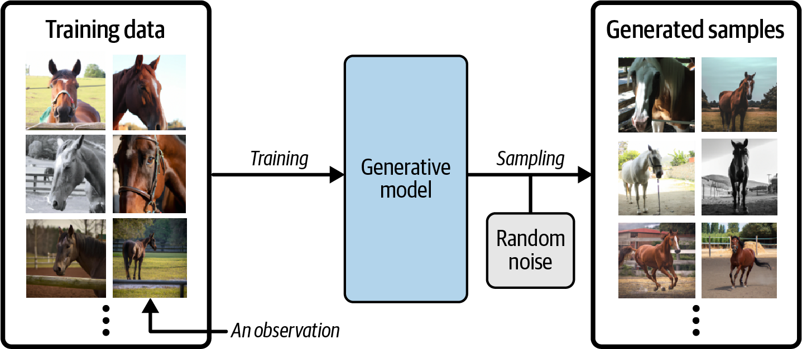

Generative Versus Discriminative Modeling
In order to truly understand what generative modeling aims to achieve and why this is important, it is useful to compare it to its counterpart, discriminative modeling. If you have studied machine learning, most problems you will have faced will have most likely been discriminative in nature. To understand the difference, let’s look at an example.

Suppose we have a dataset of paintings, some painted by Van Gogh and some by other artists. With enough data, we could train a discriminative model to predict if a given painting was painted by Van Gogh. Our model would learn that certain colors, shapes, and textures are more likely to indicate that a painting is by the Dutch master, and for paintings with these features, the model would upweight its prediction accordingly. Figure 1-2 shows the discriminative modeling process—note how it differs from the generative modeling process shown in Figure 1-1.

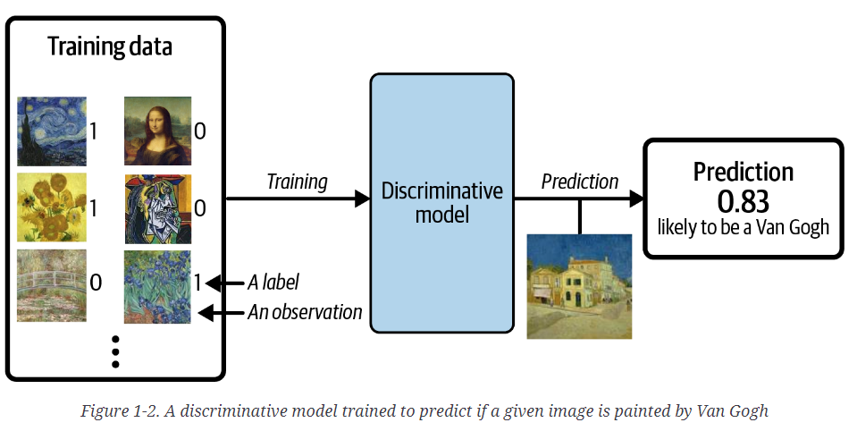
When performing discriminative modeling, each observation in the training data has a label. For a binary classification problem such as our artist discriminator, Van Gogh paintings would be labeled 1 and non–Van Gogh paintings labeled 0. Our model then learns how to discriminate between these two groups and outputs the probability that a new observation has label 1—i.e., that it was painted by Van Gogh.
In contrast, generative modeling doesn’t require the dataset to be labeled because it concerns itself with generating entirely new images, rather than trying to predict a label of a given image.
Let’s define these types of modeling formally, using mathematical notation:
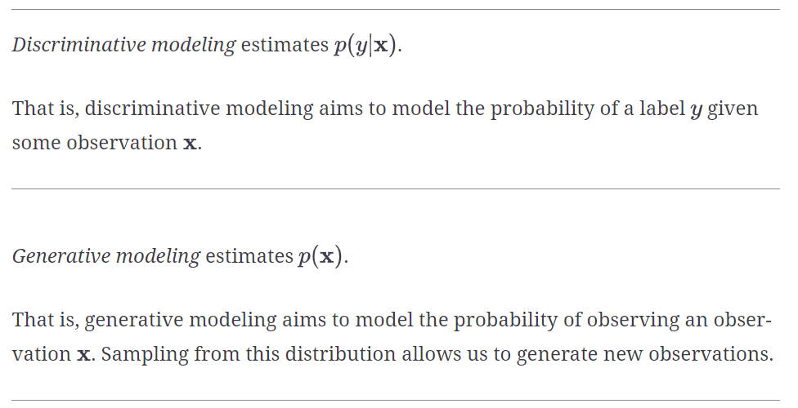
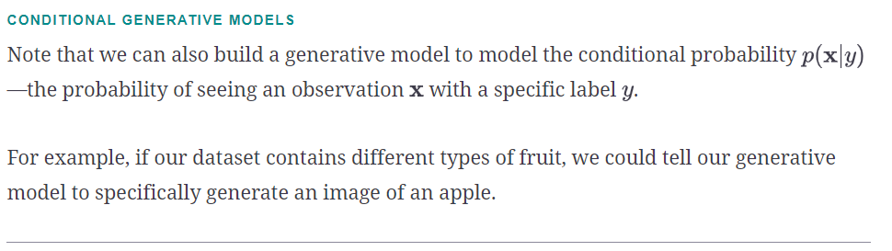
An important point to note is that even if we were able to build a perfect discriminative model to identify Van Gogh paintings, it would still have no idea how to create a painting that looks like a Van Gogh. It can only output probabilities against existing images, as this is what it has been trained to do. We would instead need to train a generative model and sample from this model to generate images that have a high chance of belonging to the original training dataset.

The Generative Modeling Framework
We can capture our motivations and goals for building a generative model in the following framework.
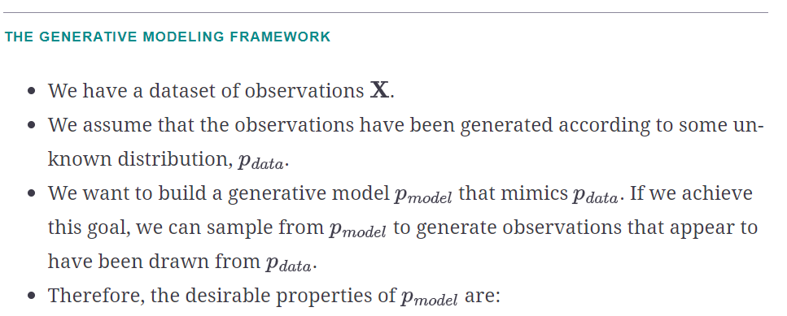
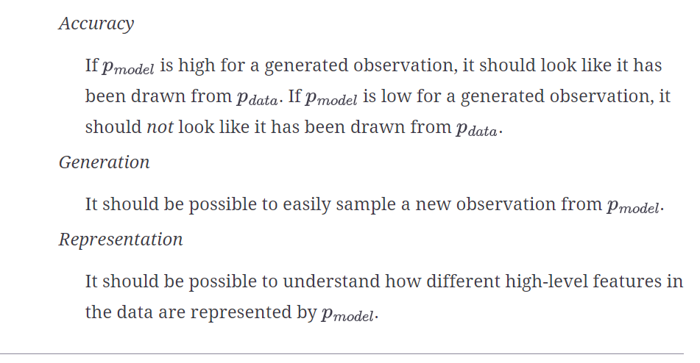

Core Probability Theory
We have already seen that generative modeling is closely connected to statistical modeling of probability distributions. Therefore, it now makes sense to introduce some core probabilistic and statistical concepts that will be used throughout this book to explain the theoretical background of each model.
If you have never studied probability or statistics, don’t worry. To build many of the deep learning models that we shall see later in this book, it is not essential to have a deep understanding of statistical theory. However, to gain a full appreciation of the task that we are trying to tackle, it’s worth trying to build up a solid understanding of basic probabilistic theory. This way, you will have the foundations in place to understand the different families of generative models that will be introduced later in this chapter.
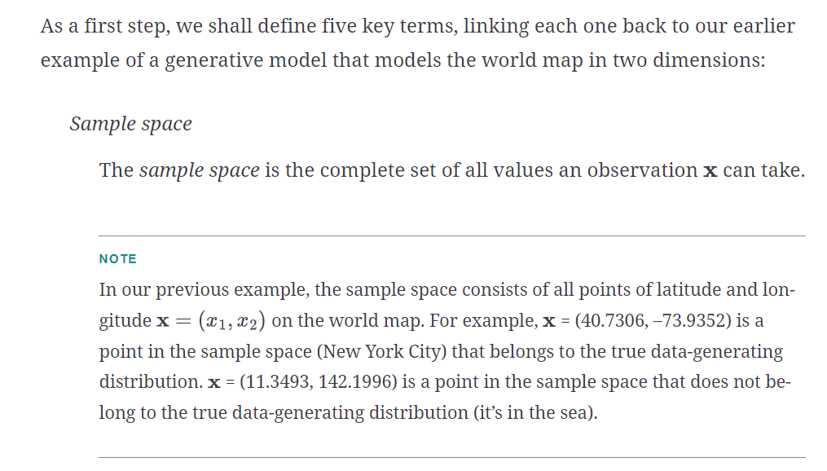
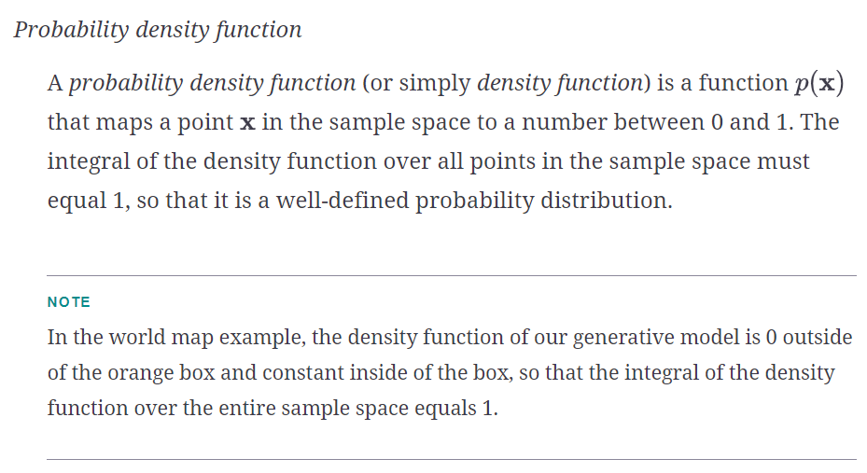
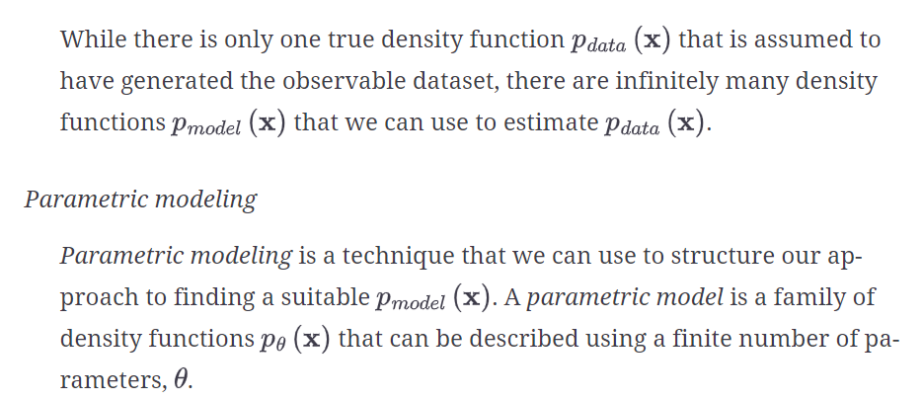
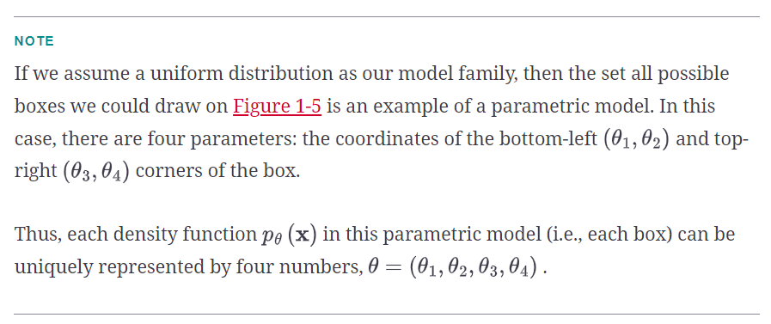
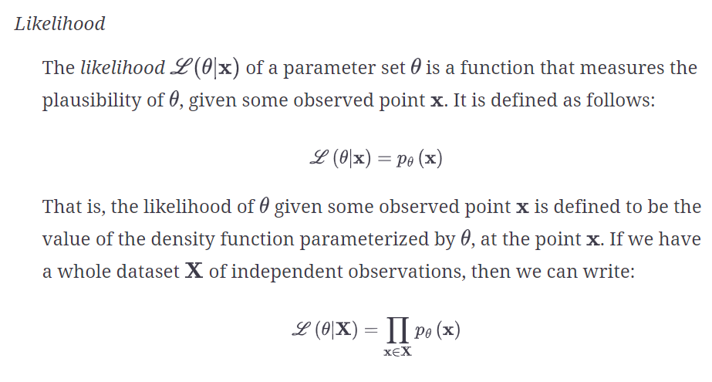

NOTE
In the world map example, an orange box that only covered the left half of the map would have a likelihood of 0—it couldn’t possibly have generated the dataset, as we have observed points in the right half of the map. The orange box in Figure 1-5 has a positive likelihood, as the density function is positive for all data points under this model.
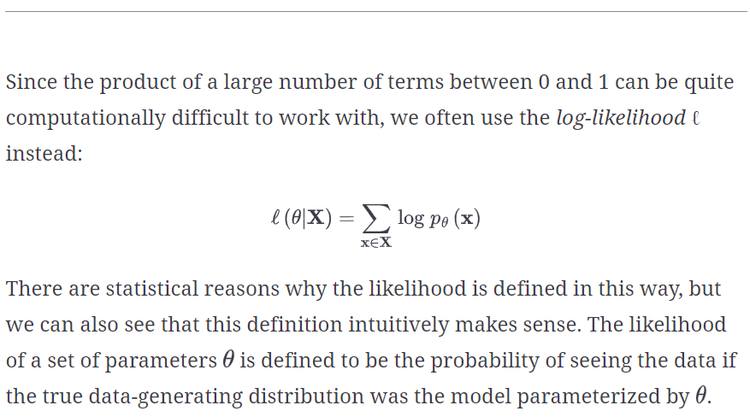
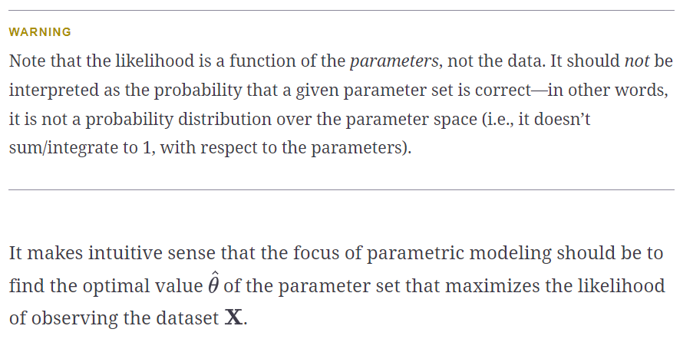
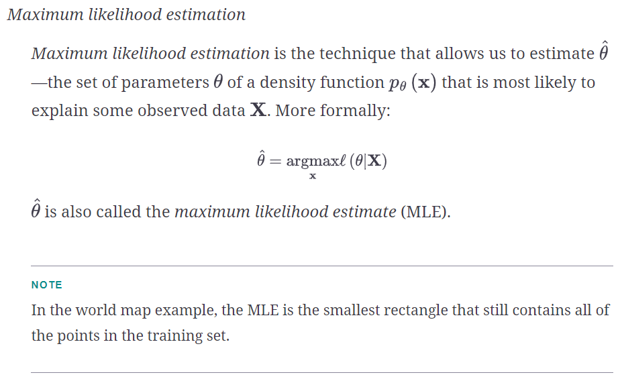
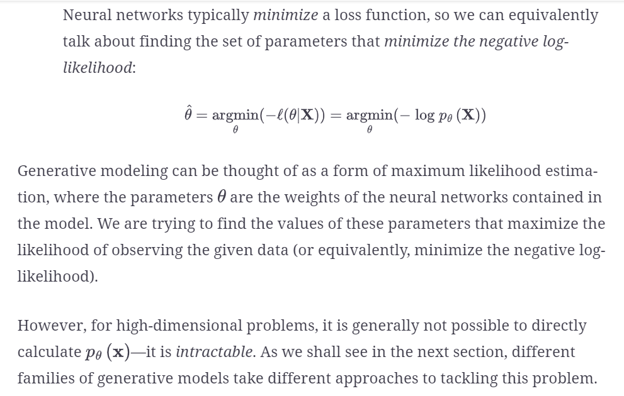

Generative Model Taxonomy
While all types of generative models ultimately aim to solve the same task, they all take slightly different approaches to modeling the density function pƟ(𝐱). Broadly speaking, there are three possible approaches:
- Explicitly model the density function, but constrain the model in some way, so that the density function is tractable (i.e., it can be calculated).
- Explicitly model a tractable approximation of the density function.
- Implicitly model the density function, through a stochastic process that directly generates data.
These are shown in Figure 1-10 as a taxonomy, alongside the six families of generative models that we will explore in Part II of this book. Note that these families are not mutually exclusive—there are many examples of models that are hybrids between two different kinds of approaches. You should think of the families as different general approaches to generative modeling, rather than explicit model architectures.
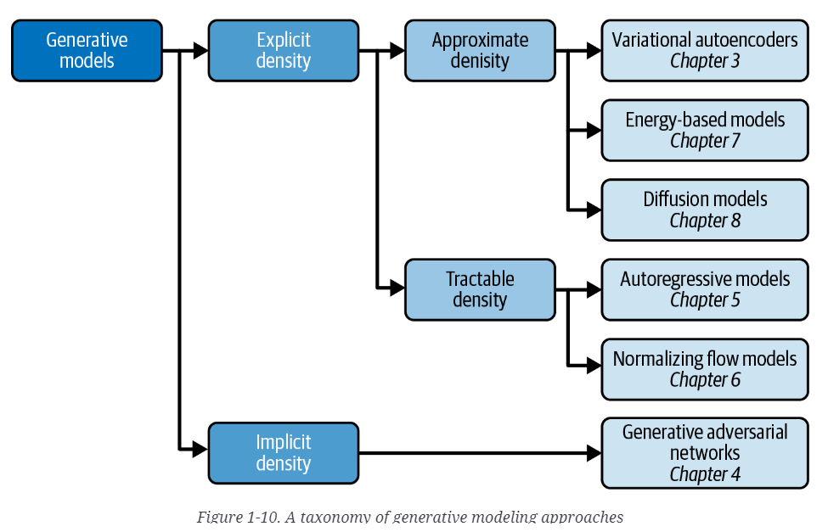
The first split that we can make is between models where the probability density function p(𝐱) is modeled explicitly and those where it is modeled implicitly.
Implicit density models do not aim to estimate the probability density at all, but instead focus solely on producing a stochastic process that directly generates data. The best-known example of an implicit generative model is a generative adversarial network. We can further split explicit density models into those that directly optimize the density function (tractable models) and those that only optimize an approximation of it.

Tractable models place constraints on the model architecture, so that the density function has a form that makes it easy to calculate. For example, autoregressive models impose an ordering on the input features, so that the output can be generated sequentially—e.g., word by word, or pixel by pixel. Normalizing flow models apply a series of tractable, invertible functions to a simple distribution, in order to generate more complex distributions.

Approximate density models include variational autoencoders, which introduce a latent variable and optimize an approximation of the joint density function. Energy-based models also utilize approximate methods, but do so via Markov chain sampling, rather than variational methods. Diffusion models approximate the density function by training a model to gradually denoise a given image that has been previously corrupted.

A common thread that runs through all of the generative model family types is deep learning. Almost all sophisticated generative models have a deep neural network at their core, because they can be trained from scratch to learn the complex relationships that govern the structure of the data, rather than having to be hardcoded with information a priori. We’ll explore deep learning in Chapter 2, with practical examples of how to get started building your own deep neural networks.

The Generative Deep Learning Codebase
The final section of this chapter will get you set up to start building generative deep learning models by introducing the codebase that accompanies this book.

TIP
Many of the examples in this book are adapted from the excellent open source implementations that are available through the Keras website. I highly recommend you check out this resource, as new models and examples are constantly being added.

Cloning the Repository
git clone https://github.com/davidADSP/Generative_Deep_Learning_2nd_Edition.git

Chapter 2. Deep Learning
Deep learning is a class of machine learning algorithms that uses multiple stacked layers of processing units to learn high-level representations from unstructured data.

The MLP is a discriminative (rather than generative) model, but supervised learning will still play a role in many types of generative models

RUNNING THE CODE FOR THIS EXAMPLE
The code for this example can be found in the Jupyter notebook located at notebooks/02_deeplearning/01_mlp/mlp.ipynb in the book repository.

Building the Model
In Keras you can either define the structure of a neural network as a Sequential model or using the functional API.

A Sequential model is useful for quickly defining a linear stack of layers (i.e., where one layer follows on directly from the previous layer without any branching). We can define our MLP model using the Sequential class

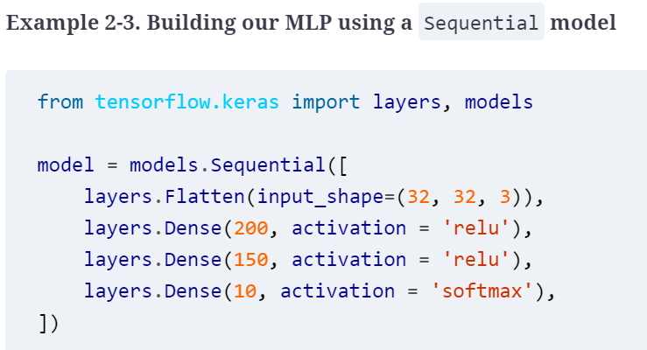
Example 2-4 shows the same MLP coded using the functional API. When using the functional API, we use the Model class to define the overall input and output layers of the model.
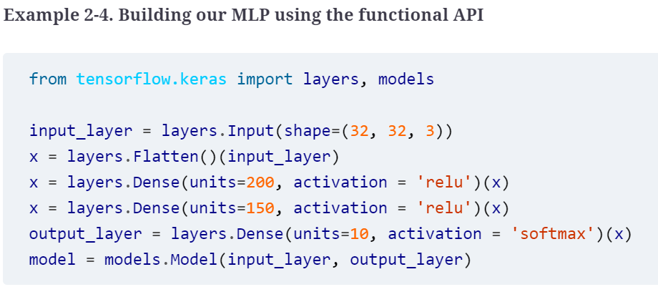
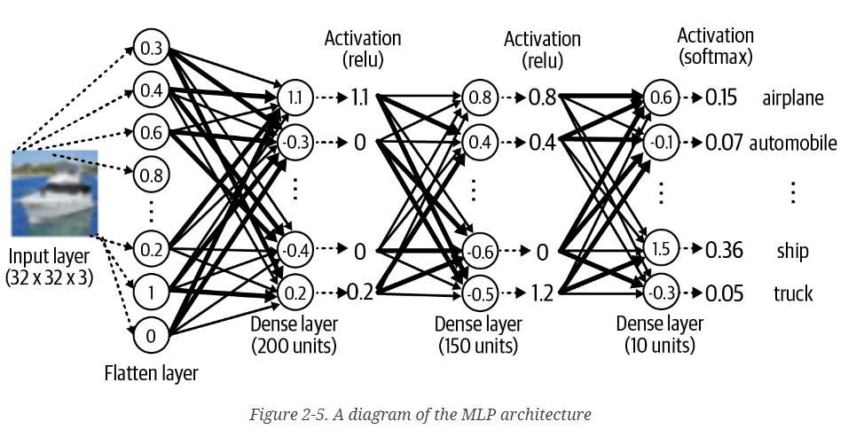
Let’s now look in more detail at the different layers and activation functions used within the MLP.

Layers
To build our MLP, we used three different types of layers: Input, Flatten, and Dense.

The Input layer is an entry point into the network. We tell the network the shape of each data element to expect as a tuple. Notice that we do not specify the batch size; this isn’t necessary as we can pass any number of images into the Input layer simultaneously. We do not need to explicitly state the batch size in the Input layer definition.

Next we flatten this input into a vector, using a Flatten layer. This results in a vector of length 3,072 (= 32 × 32 × 3). The reason we do this is because the subsequent Dense layer requires that its input is flat, rather than a multidimensional array. As we shall see later, other layer types require multidimensional arrays as input, so you need to be aware of the required input and output shape of each layer type to understand when it is necessary to use Flatten.

The Dense layer is one of the most fundamental building blocks of a neural network. It contains a given number of units that are densely connected to the previous layer—that is, every unit in the layer is connected to every unit in the previous layer, through a single connection that carries a weight (which can be positive or negative). The output from a given unit is the weighted sum of the inputs it receives from the previous layer, which is then passed through a nonlinear activation function before being sent to the following layer. The activation function is critical to ensure the neural network is able to learn complex functions and doesn’t just output a linear combination of its inputs.

Example 2-5. A ReLU activation function defined as part of a Dense layer
x = layers.Dense(units=200, activation = 'relu')(x)

Example 2-6. A ReLU activation function defined as its own layer
x = layers.Dense(units=200)(x)
x = layers.Activation('relu')(x)
In our example, we pass the input through two Dense layers, the first with 200 units and the second with 150, both with ReLU activation functions.

Chapter 3. Variational Autoencoders

The Autoencoder Architecture
An autoencoder is a neural network made up of two parts:
- An encoder network that compresses high-dimensional input data such as an image into a lower-dimensional embedding vector
- A decoder network that decompresses a given embedding vector back to the original domain (e.g., back to an image)

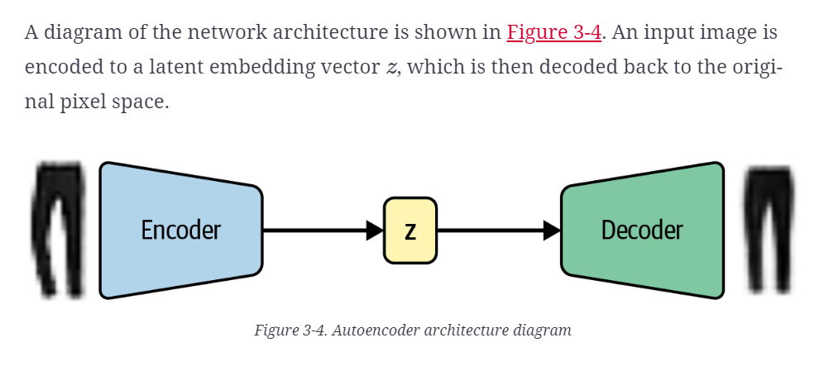
The autoencoder is trained to reconstruct an image, after it has passed through the encoder and back out through the decoder. This may seem strange at first—why would you want to reconstruct a set of images that you already have available to you? However, as we shall see, it is the embedding space (also called the latent space) that is the interesting part of the autoencoder, as sampling from this space will allow us to generate new images.

Let’s first define what we mean by an embedding. The embedding (z) is a compression of the original image into a lower-dimensional latent space. The idea is that by choosing any point in the latent space, we can generate novel images by passing this point through the decoder, since the decoder has learned how to convert points in the latent space into viable images.
In our example, we will embed images into a two-dimensional latent space. This will help us to visualize the latent space, since we can easily plot points in 2D. In practice, the latent space of an autoencoder will usually have more than two dimensions in order to have more freedom to capture greater nuance in the images.
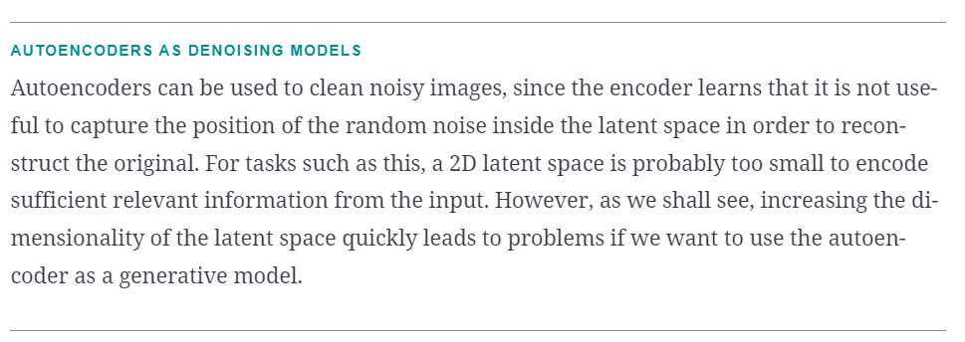

The Encoder
In an autoencoder, the encoder’s job is to take the input image and map it to an embedding vector in the latent space. The architecture of the encoder we will be building
encoder_input = layers.Input(
shape=(32, 32, 1), name = "encoder_input")
x = layers.Conv2D(32, (3, 3), strides = 2, activation = 'relu', padding="same")(
encoder_input)
x = layers.Conv2D(64, (3, 3), strides = 2, activation = 'relu', padding="same")(x)
x = layers.Conv2D(128, (3, 3), strides = 2, activation = 'relu', padding="same")(x)
shape_before_flattening = K.int_shape(x)[1:]

x = layers.Flatten()(x)
encoder_output = layers.Dense(2, name="encoder_output")(x)

encoder = models.Model(encoder_input, encoder_output)
Define the Input layer of the encoder (the image).
Stack Conv2D layers sequentially on top of each other.
Flatten the last convolutional layer to a vector.
Connect this vector to the 2D embeddings with a Dense layer.
The Keras Model that defines the encoder—a model that takes an input image and encodes it into a 2D embedding.
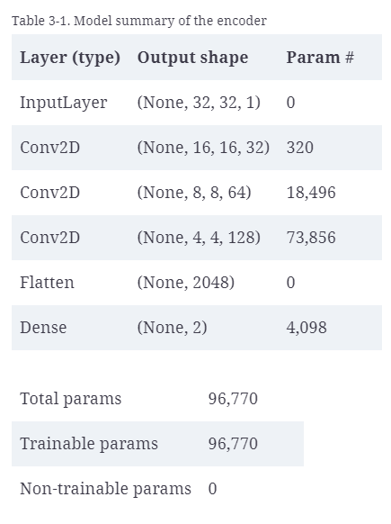
To achieve this, we first create an Input layer for the image and pass this through three Conv2D layers in sequence, each capturing increasingly high-level features. We use a stride of 2 to halve the size of the output of each layer, while increasing the number of channels. The last convolutional layer is flattened and connected to a Dense layer of size 2, which represents our two-dimensional latent space.

The Decoder
The decoder is a mirror image of the encoder—instead of convolutional layers, we use convolutional transpose layers,
decoder_input = layers.Input(shape=(2,), name="decoder_input")
x = layers.Dense(np.prod(shape_before_flattening))(decoder_input)
x = layers.Reshape(shape_before_flattening)(x)
x = layers.Conv2DTranspose(128, (3, 3), strides=2, activation = 'relu', padding="same")(x)
x = layers.Conv2DTranspose(64, (3, 3), strides=2, activation = 'relu', padding="same"
)(x)
x = layers.Conv2DTranspose(32, (3, 3), strides=2, activation = 'relu', padding="same"
)(x)

decoder_output = layers.Conv2D(
1,
(3, 3),
strides = 1,
activation="sigmoid",
padding="same",
name="decoder_output"
)(x)

decoder = models.Model(decoder_input, decoder_output)
Define the Input layer of the decoder (the embedding).
Connect the input to a Dense layer.
Reshape this vector into a tensor that can be fed as input into the first Conv2DTranspose layer.
Stack Conv2DTranspose layers on top of each other.
The Keras Model that defines the decoder—a model that takes an embedding in the latent space and decodes it into the original image domain.

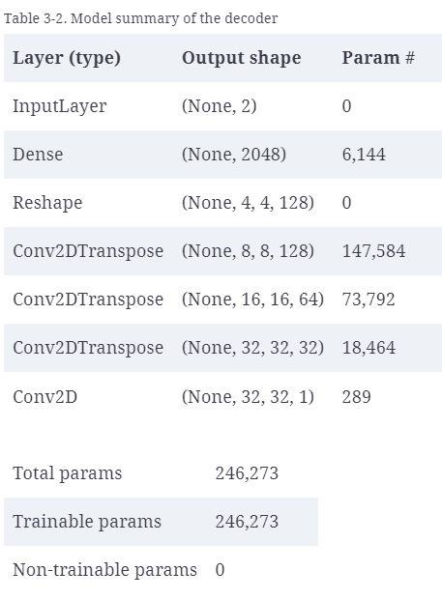

Joining the Encoder to the Decoder
To train the encoder and decoder simultaneously, we need to define a model that will represent the flow of an image through the encoder and back out through the decoder.

The full autoencoder
autoencoder = Model(encoder_input, decoder(encoder_output))
The Keras Model that defines the full autoencoder—a model that takes an image and passes it through the encoder and back out through the decoder to generate a reconstruction of the original image.

Now that we’ve defined our model, we just need to compile it with a loss function and optimizer, The loss function is usually chosen to be either the root mean squared error (RMSE) or binary cross-entropy between the individual pixels of the original image and the reconstruction.

Compiling the autoencoder
# Compile the autoencoder
autoencoder.compile(optimizer="adam", loss="binary_crossentropy")

CHOOSING THE LOSS FUNCTION
Optimizing for RMSE means that your generated output will be symmetrically distributed around the average pixel values (because an overestimation is penalized equivalently to an underestimation).
On the other hand, binary cross-entropy loss is asymmetrical—it penalizes errors toward the extremes more heavily than errors toward the center. For example, if the true pixel value is high (say 0.7), then generating a pixel with value 0.8 is penalized more heavily than generating a pixel with value 0.6. If the true pixel value is low (say 0.3), then generating a pixel with value 0.2 is penalized more heavily than generating a pixel with value 0.4.
This has the effect of binary cross-entropy loss producing slightly blurrier images than RMSE loss (as it tends to push predictions toward 0.5), but sometimes this is desirable as RMSE can lead to obviously pixelized edges.
There is no right or wrong choice—you should choose whichever works best for your use case after experimentation.

Training the autoencoder
autoencoder.fit(
x_train,
x_train,
epochs=5,
batch_size=100,
shuffle=True,
validation_data=(x_test, x_test),
)

Reconstructing Images
We can test the ability to reconstruct images by passing images from the test set through the autoencoder and comparing the output to the original images.

Reconstructing images using the autoencoder
example_images = x_test[:5000]
predictions = autoencoder.predict(example_images)

you can see some examples of original images (top row), the 2D vectors after encoding, and the reconstructed items after decoding (bottom row).
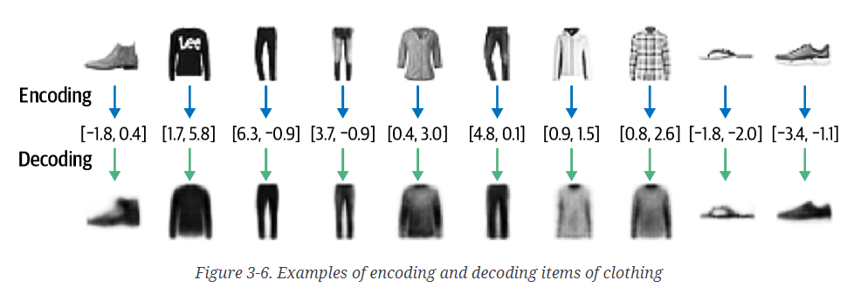
Notice how the reconstruction isn’t perfect—there are still some details of the original images that aren’t captured by the decoding process, such as logos. This is because by reducing each image to just two numbers, we naturally lose some information.

Visualizing the Latent Space
We can visualize how images are embedded into the latent space by passing the test set through the encoder and plotting the resulting embeddings,

Embedding images using the encoder
embeddings = encoder.predict(example_images)

plt.figure(figsize=(8, 8))
plt.scatter(embeddings[:, 0], embeddings[:, 1], c="black", alpha=0.5, s=3)
plt.show()

In order to better understand how this latent space is structured, we can make use of the labels that come with the Fashion-MNIST dataset, describing the type of item in each image. There are 10 groups altogether,
ID | Clothing label
0 | T-shirt/top
1 | Trouser
2 | Pullover
3 | Dress
4 | Coat
5 | Sandal
6 | Shirt
7 | Sneaker
8 | Bag
9 | Ankle boot
The Fashion-MNIST labels

Generating New Images
We can generate novel images by sampling some points in the latent space and using the decoder to convert these back into pixel space,

Generating novel images using the decoder
mins, maxs = np.min(embeddings, axis=0), np.max(embeddings, axis=0)
sample = np.random.uniform(mins, maxs, size=(18, 2))
reconstructions = decoder.predict(sample)
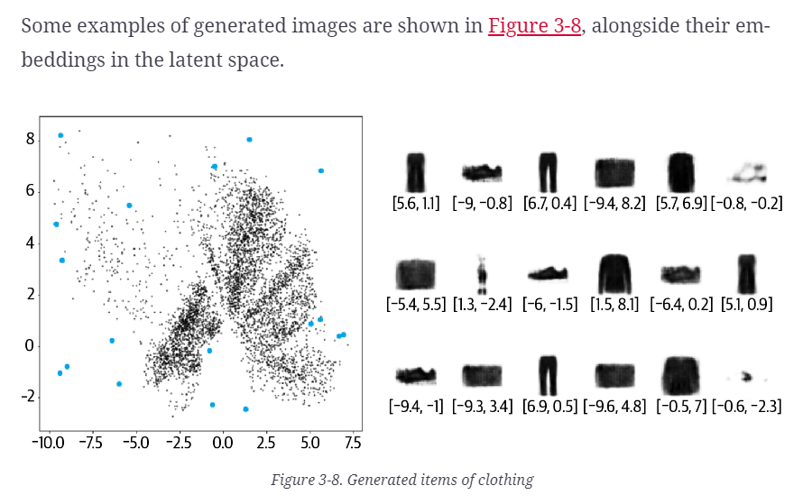
Each blue dot maps to one of the images shown on the right of the diagram, with the embedding vector shown underneath. Notice how some of the generated items are more realistic than others. Why is this?
To answer this, let’s first make a few observations about the overall distribution of points in the latent space,
- Some clothing items are represented over a very small area and others over a much larger area.
- The distribution is not symmetrical about the point (0, 0), or bounded. For example, there are far more points with positive y-axis values than negative, and some points even extend to a y-axis value > 8.
- There are large gaps between colors containing few points.

Firstly, we can see that if we pick points uniformly in a bounded space that we define, we’re more likely to sample something that decodes to look like a bag (ID 8) than an ankle boot (ID 9) because the part of the latent space carved out for bags (orange) is larger than the ankle boot area (red).
Secondly, it is not obvious how we should go about choosing a random point in the latent space, since the distribution of these points is undefined. Technically, we would be justified in choosing any point in the 2D plane! It’s not even guaranteed that points will be centered around (0, 0). This makes sampling from our latent space problematic.

Lastly, we can see holes in the latent space where none of the original images are encoded. For example, there are large white spaces at the edges of the domain—the autoencoder has no reason to ensure that points here are decoded to recognizable clothing items as very few images in the training set are encoded here.
Even points that are central may not be decoded into well-formed images. This is because the autoencoder is not forced to ensure that the space is continuous. For example, even though the point (–1, –1) might be decoded to give a satisfactory image of a sandal, there is no mechanism in place to ensure that the point (–1.1, –1.1) also produces a satisfactory image of a sandal.
In two dimensions this issue is subtle; the autoencoder only has a small number of dimensions to work with, so naturally it has to squash clothing groups together, resulting in the space between clothing groups being relatively small. However, as we start to use more dimensions in the latent space to generate more complex images such as faces, this problem becomes even more apparent. If we give the autoencoder free rein over how it uses the latent space to encode images, there will be huge gaps between groups of similar points with no incentive for the spaces in between to generate well-formed images.
In order to solve these three problems, we need to convert our autoencoder into a variational autoencoder.

NLP
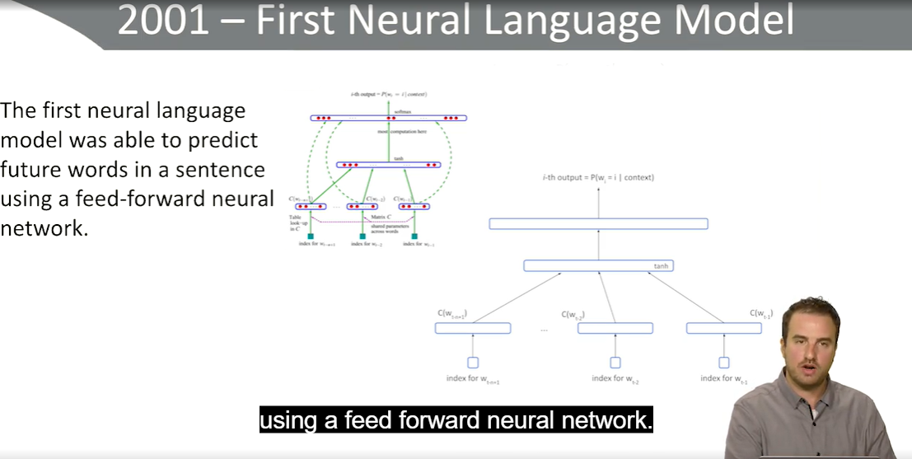
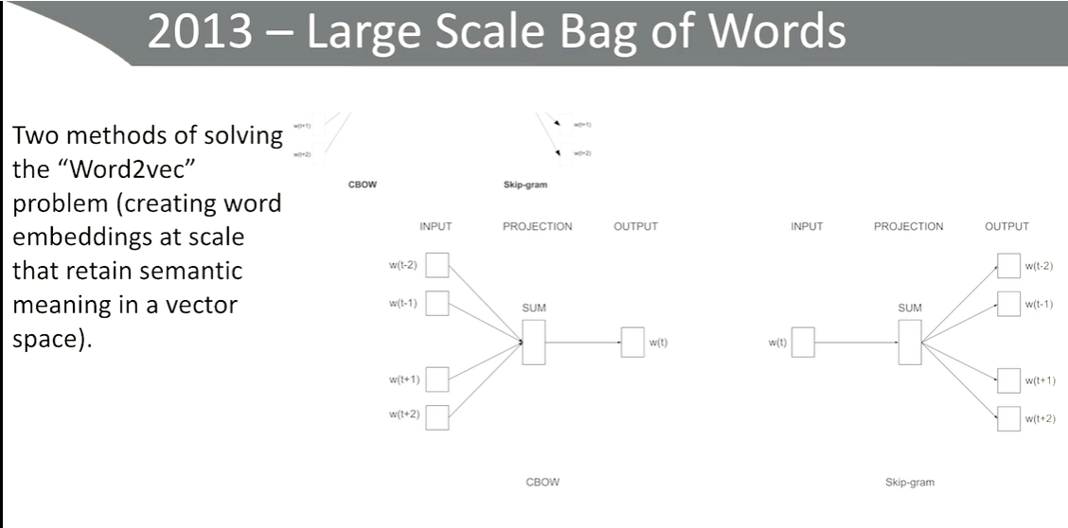
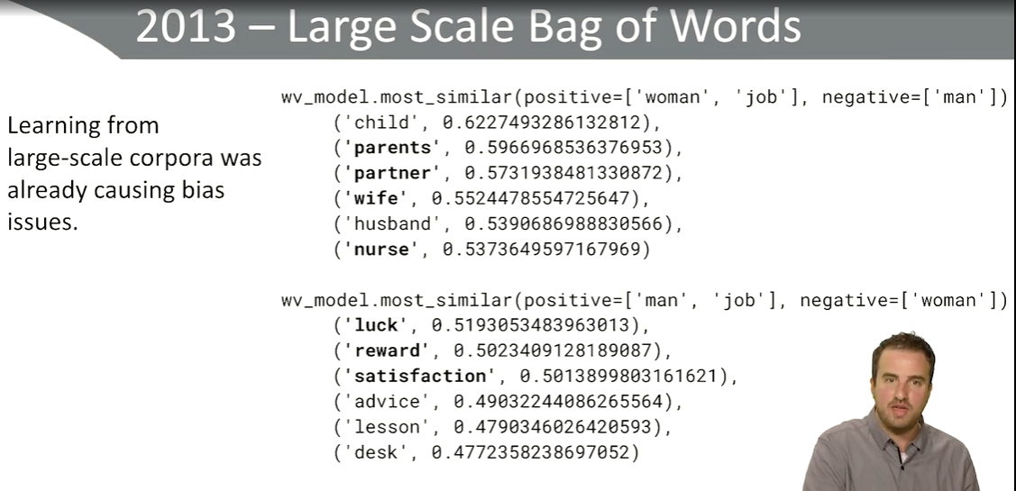
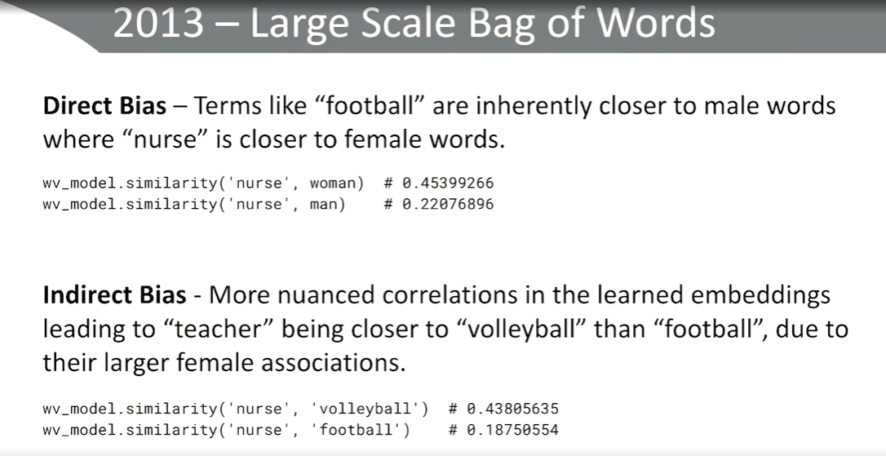
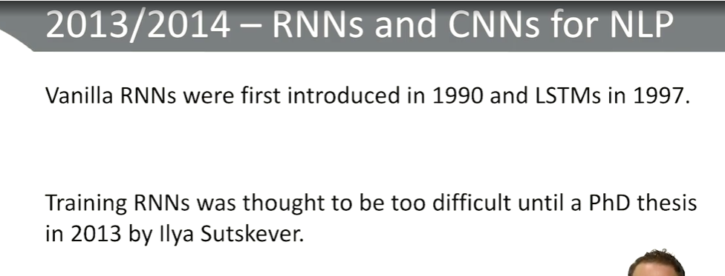
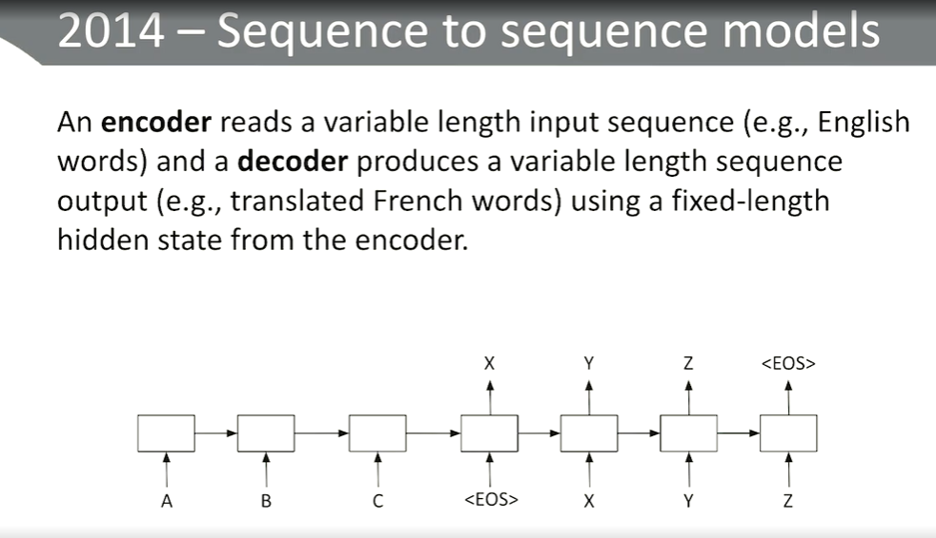
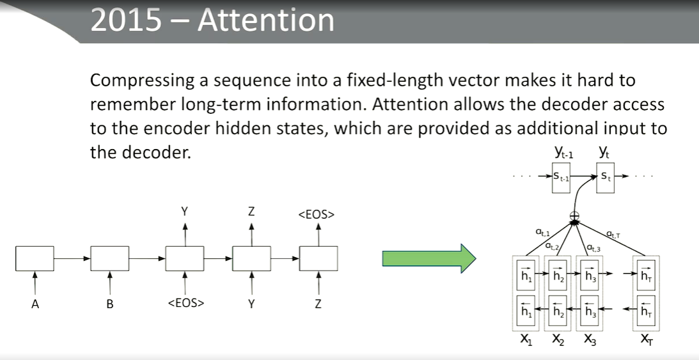
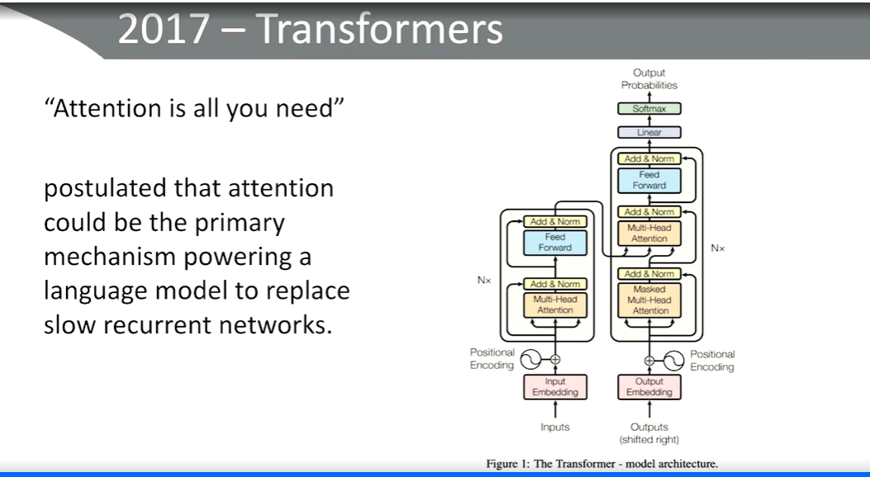
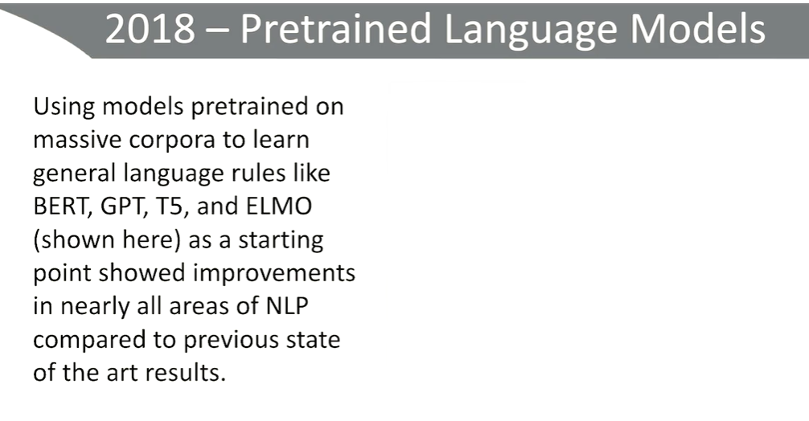
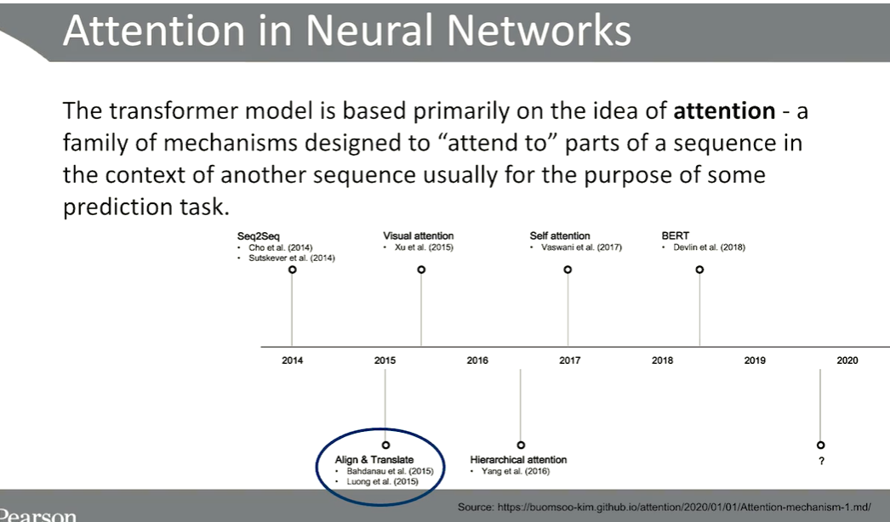
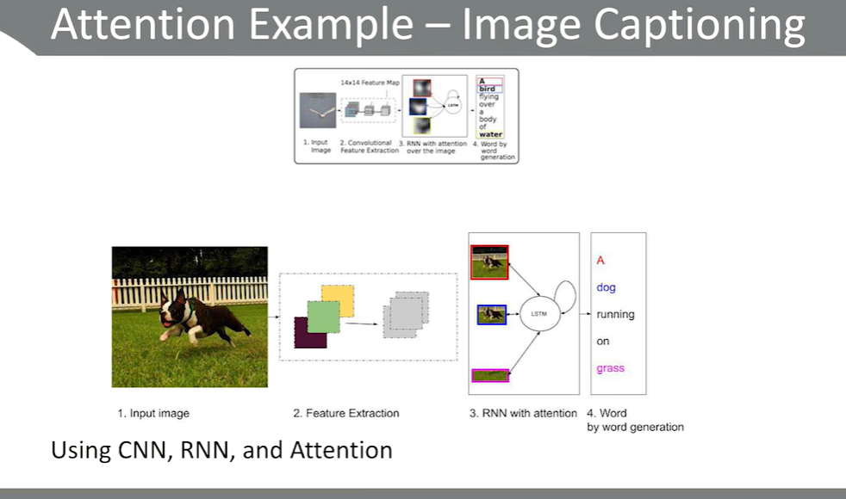
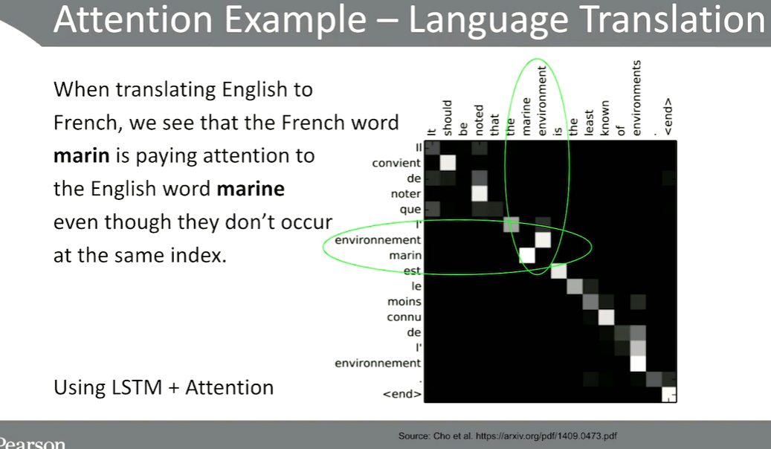
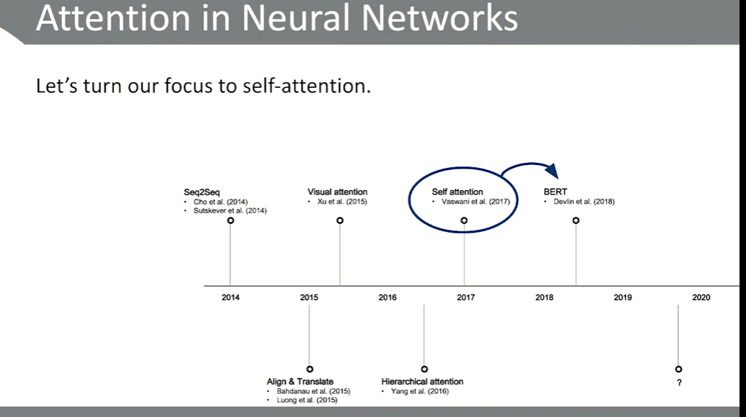
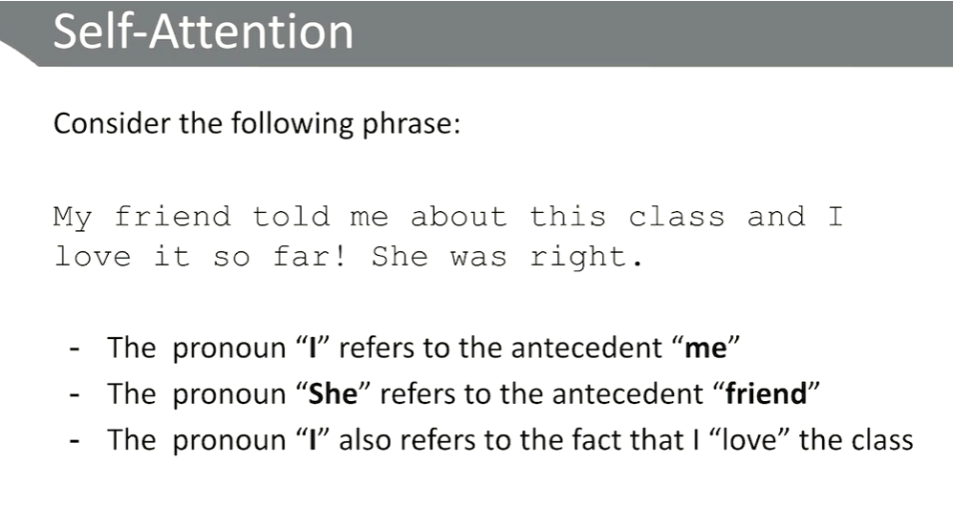
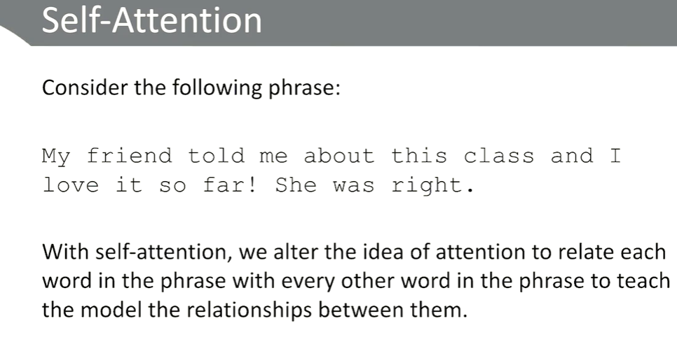
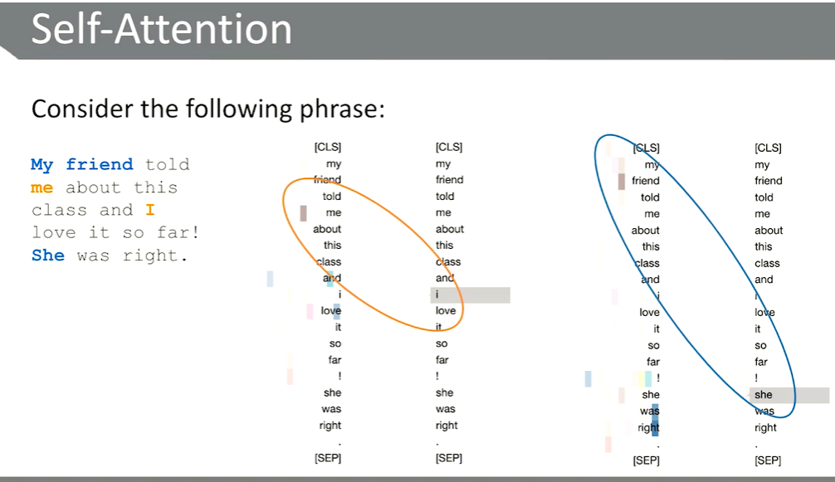
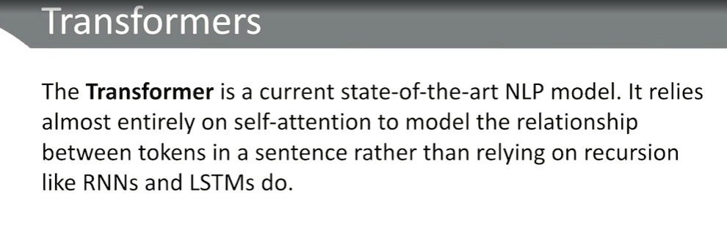
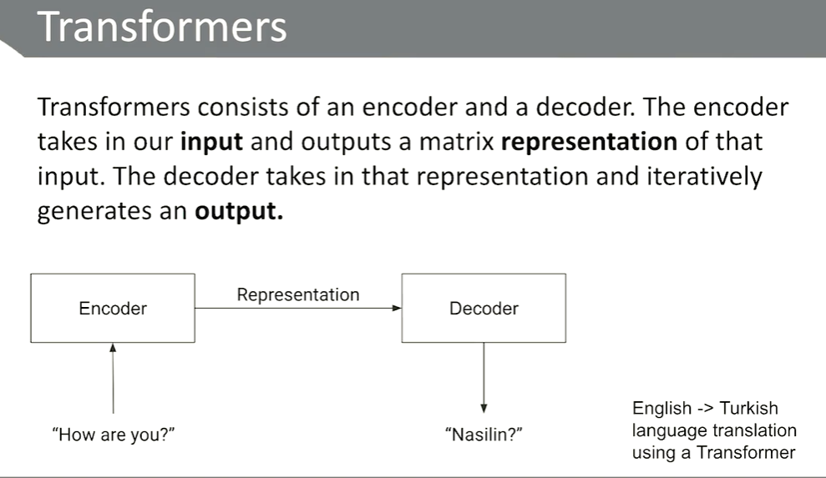
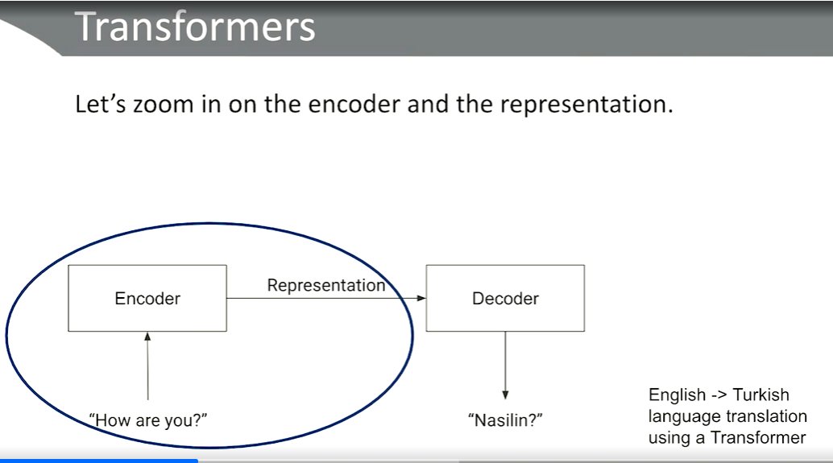
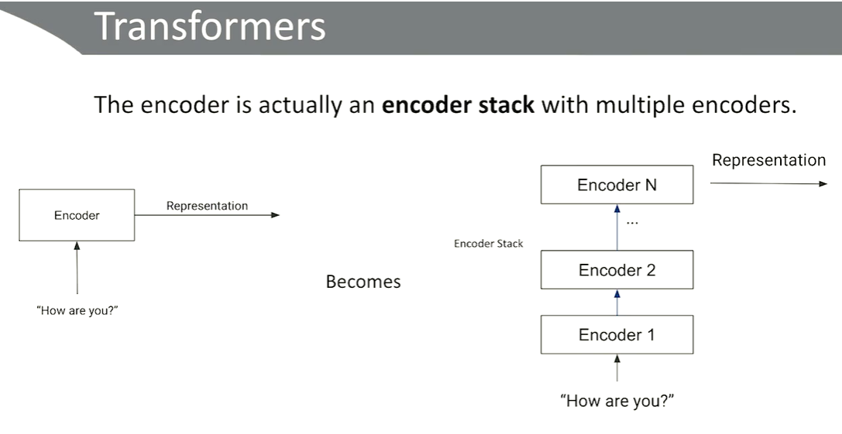
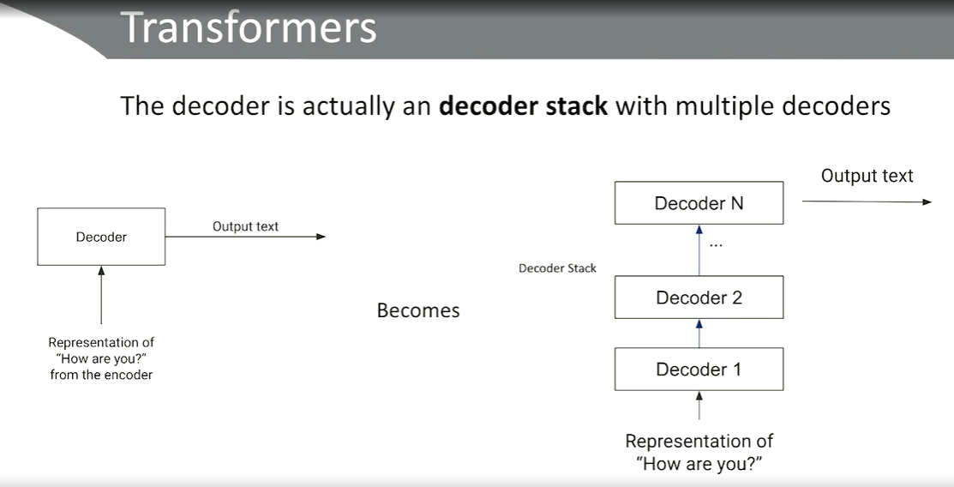
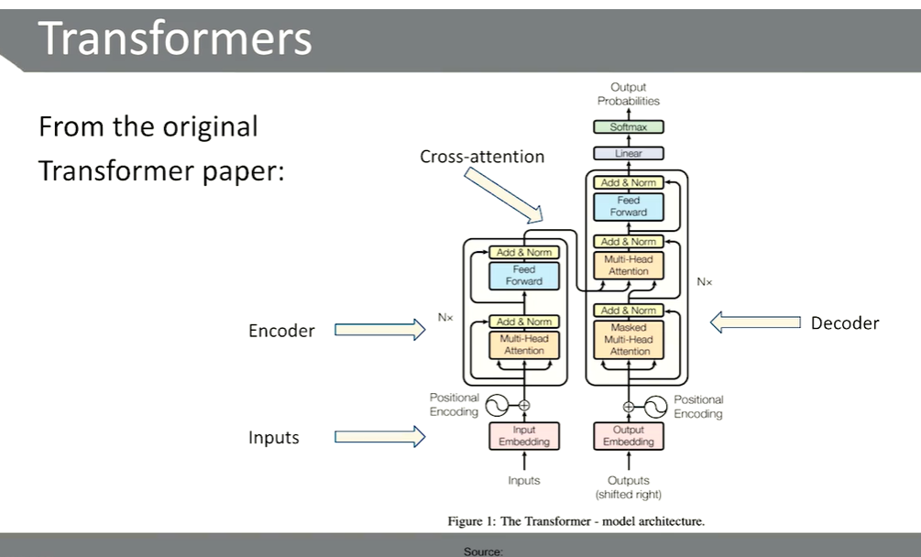
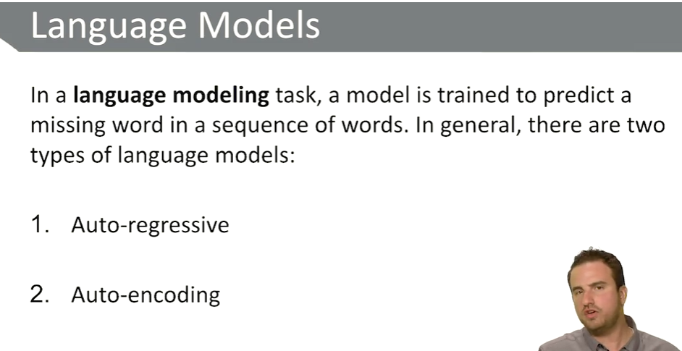
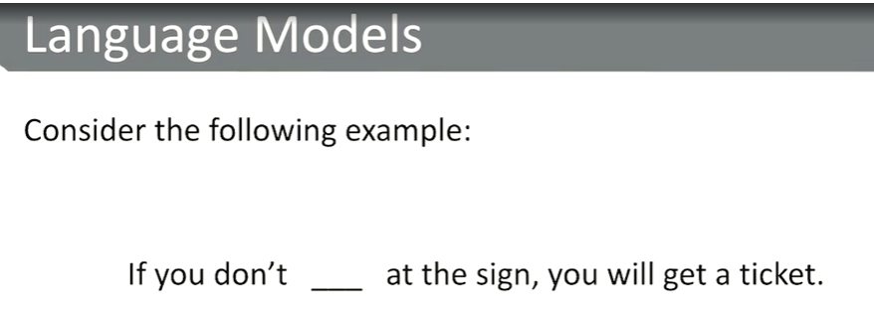
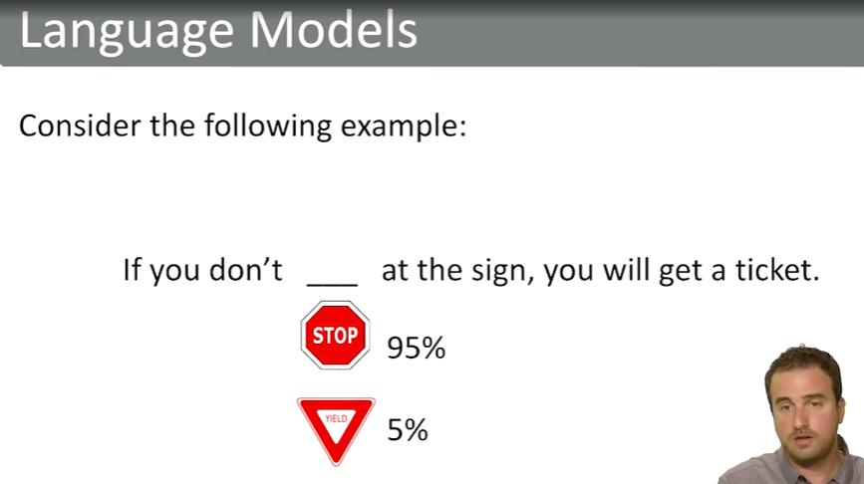
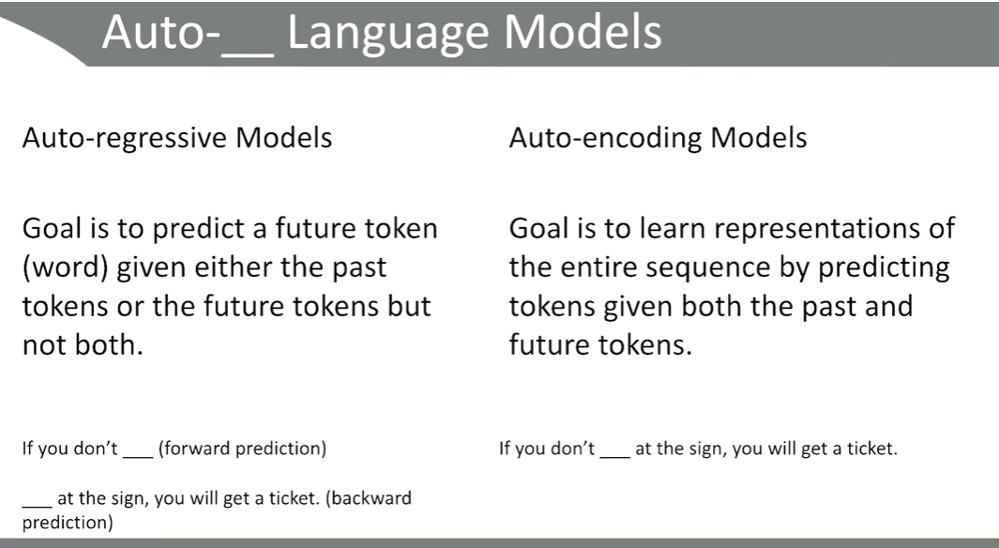
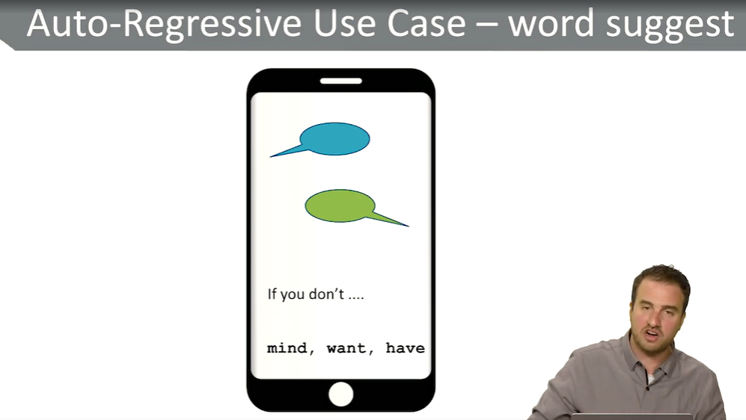
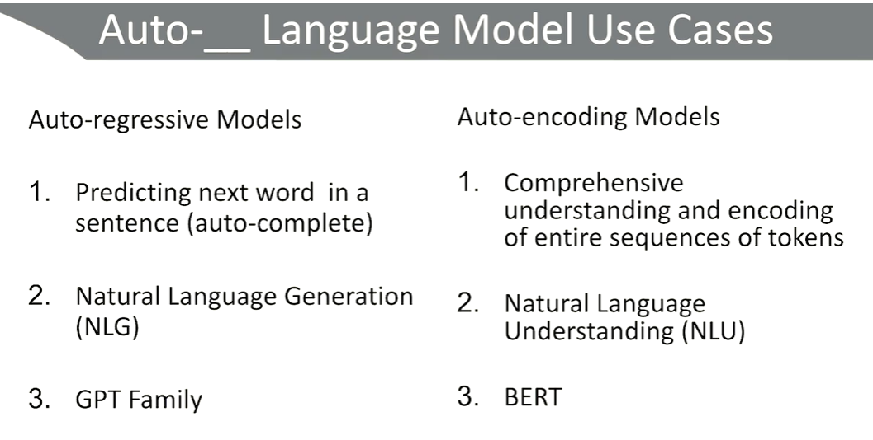
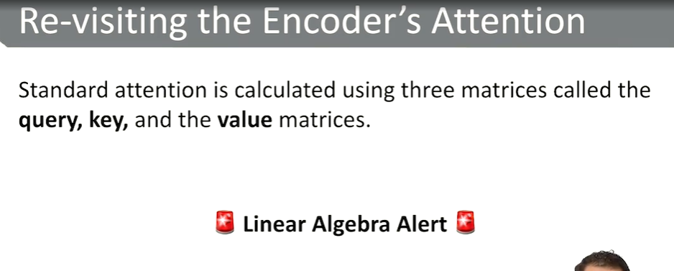
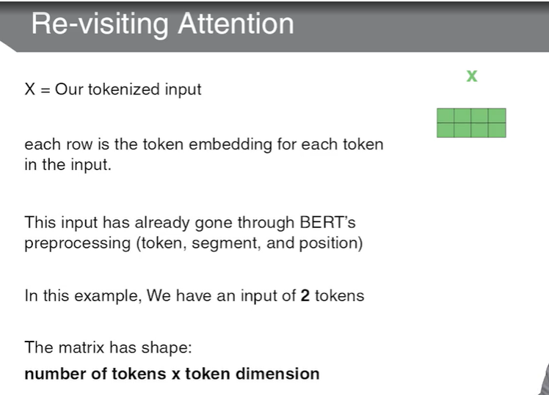
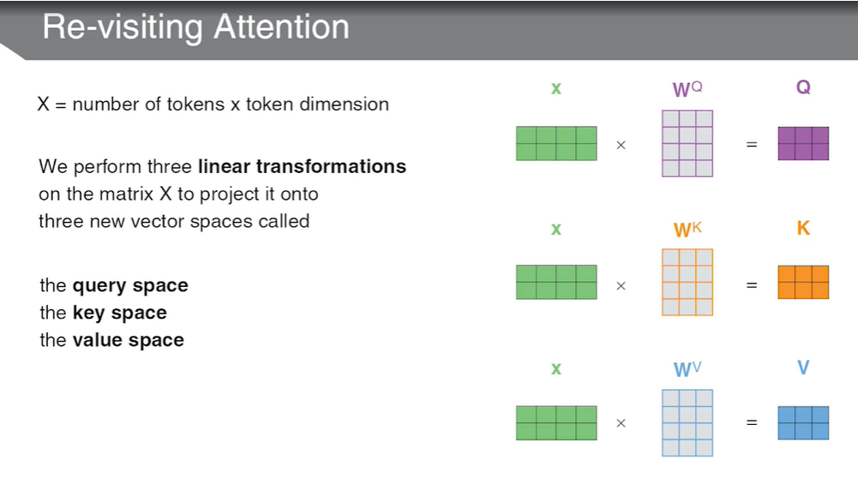
we're going to revisit the attention that is prominent in the encoder of the transformer architecture. Now, standard attention is calculated using three matrices called query, key, and value matrices.

we started with X number of tokens by the token dimension, two by four. We then multiplied that X by a matrix, WQ, WK and WV. Each of those matrices have the dimension, token dimension, by something we call the embedding dimension. And this is so we can take our X, and change the number of columns, and compress it into a smaller matrix which still captures information about X. Our resulting matrices, Q, K, and V, query, key and value, have the dimension number of tokens. So still two rows. And embedding dimension. In our example, that's three.
So if I said the phrase, I love cats, that's not a question, but I'm saying it for a reason. And the key matrix represents how important each word is to the overall query that I have. The value matrix intuitively represents the contextless meaning of our input tokens. V is basically just a compressed version of X. Where X were embeddings of each of our tokens, each of our words, so is V. V is just meant to represent a smaller, more compressed version of the contextless meaning of our input tokens. And when I say contextless, I mean, pre-attention. I mean pre looking at all of the other tokens that are words.
. The formula though, as a whole, is the soft max of the query matrix times the key matrix, and this t for transpose just makes the dimensions work, but we're multiplying those two matrices together. We divide the values by the square root of our embedding dimension. In this case, it would be three. We take the soft max of that matrix, so that the numbers all add up to one representing a probability distribution. And then we multiply that whole thing by V. Now, that last step seems simple, relatively at least, but that last part of multiplying the matrix times V is what transforms V from being a contextless information about each token and to a context full representation of each token.
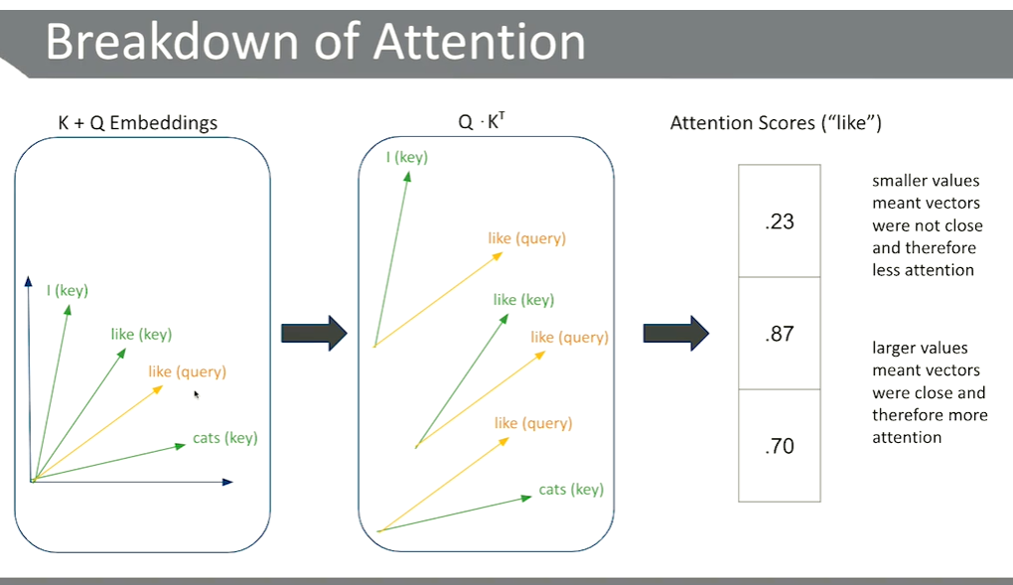
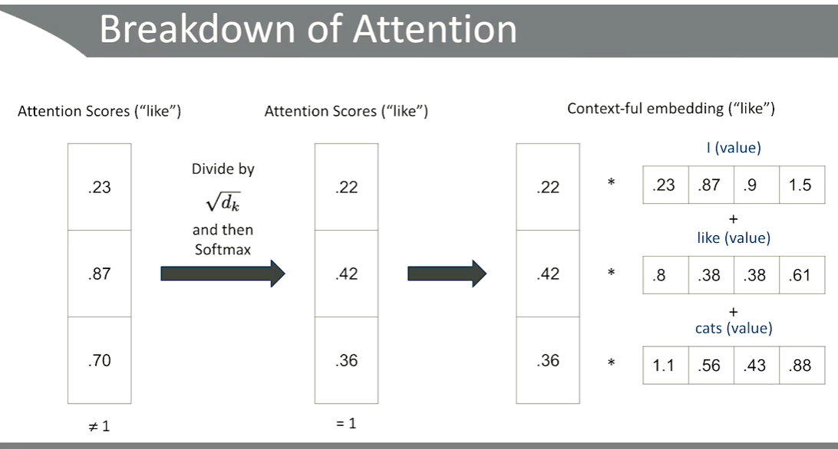
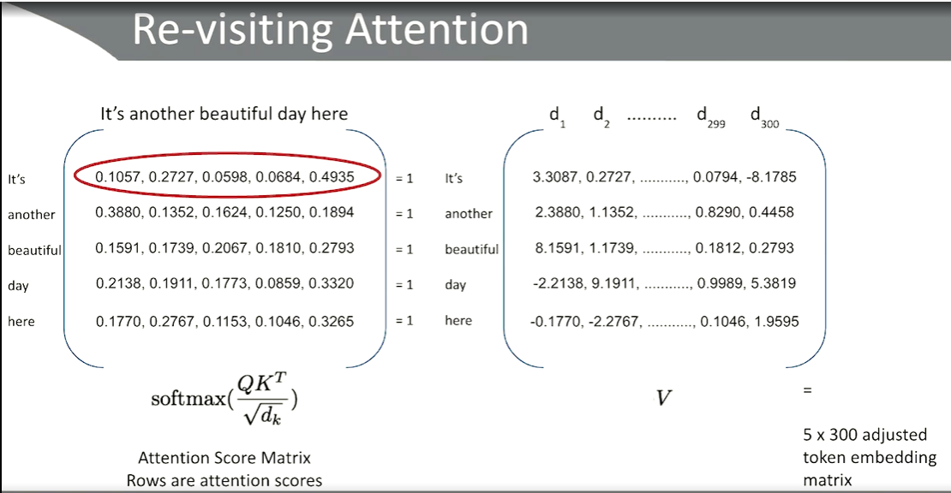

- Section 2.2, scaled dot product attention. Okay, it's time to get into the meat of how transformers actually learn and think about natural language. And to do that we're going to revisit the attention that is prominent in the encoder of the transformer architecture. Now, standard attention is calculated using three matrices called query, key, and value matrices. Now, just a quick heads up, this section is going to be pretty heavy on the linear algebra. Now, if I'm doing my job right, and I used to teach linear algebra, I'm gonna walk through this step by step to gain not just a mathematical understanding of what's going on, but also an intuitive one. And I think that's going to really make it click how the transformer is able to learn. Then we're gonna actually take a look at our first code segment to dive into how transformer, and specifically a BERT architecture, uses the self, the scale dot product attention. To start, we're gonna take a look at our input. More specifically, we're gonna take a look at our tokenized input, X, this matrix here on the right. Each row of this matrix represents a token embedding for each token in our input. So in this case, our input has already gone through BERT's pre-processing steps. We will dive into those pre-processing steps in a later lesson, but for now let's assume they've already gone through those steps. So in this example, we have two tokens in our input sequence represented by our first and second row. The four columns that we see in this matrix are what we consider or token dimension. Meaning each token is given an embedding. If we think back to our previous lesson when we talked about how in 2013, we were able to generate large scale word embeddings through Word2Vec, you can think of each embedding of each token like a Word2Vec embedding. A embedding for each token, that should in some way represent the semantic meaning of that token. So we have two tokens, two rows, and in our simple example, four dimensions in our embedding, which in practice is gonna be much bigger than four, but for the purposes of our example, four. So our X, the number of rows is two, the number of columns is four, which means we have two tokens, and our token dimension is four. Each token is given an embedding dimension of four. We take that X matrix, and we perform three linear transformations on that matrix to project it into three brand new vector spaces called the query space, the key space, and the value space. In linear algebra speak, that's just multiplying X by three different matrices. Shown here as WQ, or the weight matrix for the query space, WK, the weight matrix for the key space, and WV, the weight matrix for the value space. The output of each of these matrix multiplications is another matrix where the number of rows will be the number of tokens we've started with, two. There's still two tokens. But we'll notice in our example we've gone from four to three. Now this is just for visual demonstration purposes to show that these dimensions are different. We started with four dimensions for each token, and then we compressed it into a smaller vector space with only three columns in the matrix, but still two tokens. Now, the obvious question I hope you're asking yourself is, well, why? Why are we doing this? And it's because each matrix, Q, K, and V, have an intuitive meaning that give rise to our attention formula, which we're about to see. So recap, we started with X number of tokens by the token dimension, two by four. We then multiplied that X by a matrix, WQ, WK and WV. Each of those matrices have the dimension, token dimension, by something we call the embedding dimension. And this is so we can take our X, and change the number of columns, and compress it into a smaller matrix which still captures information about X. Our resulting matrices, Q, K, and V, query, key and value, have the dimension number of tokens. So still two rows. And embedding dimension. In our example, that's three. So why? We want to impart meaning on these matrices. And this is one of those aspects of mathematics where a mathematician who is trying to create a formula will decide or impart intuitive representations or intuitive meanings behind matrices, and then allow a training phase to actually learn the proper weight matrices, these Ws, WQ, WK, and WV. We want to learn the values in this matrix that actually impart the meaning as the architect intended. So the intended intuitive meaning of these matrices are, the query matrix is meant to represent an information that we are looking for a, a query that we have. Again, you could think about this like, every time I say words out loud, and you say words out loud, there hopefully is a point to you saying that. There's some query. Now, again, I would not confuse query with question, like you're asking a question, you have a query. The idea is more about to represent the point of you speaking in the first place. The key matrix is intuitively meant to represent the relevance of each word to our query.

What does each word mean on its own? Eventually we wanna end up with context full representations of our input tokens. A context full representation will take into account the other tokens in the sequence. At the end of the day, the query, the key, and the value matrix, all of these matrices all contain information regarding individual tokens. The difference between them is the information given some idea. So for query, it is the information regarding individual tokens as it relates to the overall goal of the sentence, the point of you speaking in the first place. K's embeddings contain information about each individual token as they relate to your query, why you said them. The V is our information regarding the tokens, their semantic meaning given no context. Just what does the word cat mean? What does the word like mean? What does the word I mean, without looking at anything else? In a vacuum, what does the value, the V, of those tokens mean? At this point, each matrix contains a representation of each token in a different vector space. So we have our X. We multiplied X by three different weight matrices to obtain three different matrices, query, key, and value. So now it's time to calculate the scaled dot product attention. And here is our formula. The scaled dot product attention takes in a query, key, and value matrix, each one, representing an embedding of each token and performs the following formula. Don't worry, we are about to break it down. The formula though, as a whole, is the soft max of the query matrix times the key matrix, and this t for transpose just makes the dimensions work, but we're multiplying those two matrices together. We divide the values by the square root of our embedding dimension. In this case, it would be three. We take the soft max of that matrix, so that the numbers all add up to one representing a probability distribution. And then we multiply that whole thing by V. Now, that last step seems simple, relatively at least, but that last part of multiplying the matrix times V is what transforms V from being a contextless information about each token and to a context full representation of each token. So this is our attention equation. It combines the query, key, and the V matrices in such a way that forces the tokens to look at each other by multiplying the matrices together. And after forcing the tokens to look at each other, we take that combination and scale our contextless representation, V, transforming it into a context full representation of our tokens. So again, let's go through that, all of it again, one by one. Let's start with the multiplication, the Q times K transpose, query times key transpose. Multiplying the query and the key matrices together result in a square matrix. And it's square in the number of dimensions is our tokens. So when we do this, if you wanna do a quick check for yourself, the dimensions after multiplying query times K transpose would be two by two, number of tokens by number of tokens. That actually represents the attention score of the tokens. If we think back to our example of the English to French translation where we show that black matrix with the white boxes representing strong attention, that's the kind of square matrix that we're calculating here. We should actually be able to see larger numbers where paying attention is happening. Where it's paying more attention, the number should be bigger. If it's paying less attention, the number should be smaller. We then divide that attention matrix, the attention scores, by the square root of the embedding dimension. In this case, that would've been the square root of three. The only reason the authors do this is to make the values smaller. And you may think I'm kidding, but I'm not. It makes the values more manageable. And if it's more manageable and smaller, it's faster to compute. And they found that dividing it by that square root and not dividing it by the square root didn't lose anything in terms of the goal of the task, which was to perform NLP. So they figured, why not do the thing that makes it faster? So they divided by the square root of three, or whatever that dimension is, and then take a soft max of the whole matrix. That means every row will end up being a probability distribution. And we're gonna actually see what that looks like. Let's go through that again in a more visual example. Let's say our input sequence is I like cats. Who could argue? When we calculate the attention scores for our tokens, the goal is to look at each token and its relevance to every other token in the sequence. So in this visual example, we're focusing on the word like as our query. We'll be calculating the attention scores for the word like. Put another way, we are hoping to end up with a vector of numbers that relate to how much every other word, including itself, relates to the word like. So in green, we have our vectors in the key space. I like cats. In orange, we have the same like vector in the query space. And remember, the query space is meant to represent the whole reason we're speaking in the first place. So when we calculate attention scores for like, what we're really saying is, how similar are these vectors to each other? Because if vectors are similar to each other, they're closer to each other, they represent a stronger relationship between them. So when we are calculating the attention scores for like, i.e. when we multiply query times K transpose, we are literally calculating a number that represents those vectors' closeness to each other, and therefore relevance of those tokens. So let's zoom in on that like query. And just to also mention, technically, the key in the query space are different vector spaces. I am showing them on the same plane just to show the visual calculation, but these technically live in different vector spaces. And you can tell they do, because like, the same word in the key and the query space are different vectors. Because again, what we're trying to actually accomplish is not calculating that these do are semantically similar to each other. We are trying to calculate the relationship between saying the word like against the general concept of I like cats. We're focusing on the word like. So when we multiply query times K transpose, we are literally calculating a number that represents how close these vectors are to each other. So like in the query space is closest to like in the key space. Now they're not the same vector, and they would be the same vector if they were the same vector space. But one of the reasons we have two different vector spaces, key and query, is that we don't actually want the same word to have the same embedding in those two spaces. Because again, we are not calculating semantics similarity. We're calculating relevance of those words against every other word. Relevance is not the same thing as semantics similarity. Because like and the query space is closest to, this angle between the vector is the smallest between like and the key space, our like score of I like cats is 0.87. It's the biggest number in our attention score. The word like in the query space is furthest from the word I in the key space. So the I score will be smaller. And then in the middle, the word like in the query space is closest to the word cats in the key space, and is between like and I, so our attention score is 0.7, somewhere between 0.23 and 0.87. Smaller values mean that the vectors were not close, and therefore we should be paying less attention to it. Larger values mean these vectors were close together, and we should be paying more attention. We can already see that the scale dot product attention, in its first act of multiplying query and key, calculating these scores and saying, okay, given the word like, this is how much you should be paying attention to the other words, including itself, but we don't want it to be paying it to itself too much. So we do wanna make sure that it's not the same vector for like, and that we are looking at the other vectors in the sequence. So these are our attention scores. So once we calculate those two together, we're gonna take that square matrix, which no longer holds a representation of each individual token by the way. That square matrix, which in this example that we're looking at here, would be two by two. Those columns no longer represent a dimension, or rather an embedding of each token. They now specifically represent a attention it should be paying attention to. Each row will represent each of our tokens, and each column also holding our tokens will show how much you should be paying attention to it. Once we do that, we're going to multiply it by our value matrix in blue. That way we actually scale each token value, so that we know how much it should be paying attention to it. That's how we end up with context full representations of our input tokens. So going back to our attention scores for like, remember we had 0.23, 0.87, and 0.7. Those numbers obviously do not add up to one. It goes over one. So once we have those attention scores that we got by multiplying the query and the key transposed matrix together, we have to divide it by the square root of our dimension, which in our example has been three, and then apply a soft max function. A soft max function will create a probability distribution, and for our purposes a little bit more importantly, make those numbers add up to one while still maintaining order. So in our case, 0.23, 0.87, and 0.7, applying a soft max to it would look something like 0.22, 0.42, and 0.36. These numbers add up to one, and they're also maintaining order. 0.87 was the largest attention score, and it is the largest probability, 0.42, in our resulting matrix. This probability distribution of 0.22, 0.42, and 0.36, now represents the probability, or rather the confidence level of how much it should be paying attention to each other token. Put another way, you could say, when focusing on the word like as our query, like why am I saying the word like? I should be paying attention to the word I, about 22% of attention, I should be paying attention to the word cats with about 36% of my attention, and I should give the rest of my attention to the word like with 42%. That's how we would interpret those numbers. We then take those probabilities, 0.22, 0.42, and 0.36, and multiply it by the value of each token. So again, focusing on like, I'm going to then take the contextless meaning of I like cats. Now, the value matrix, which we haven't touched yet, remember, those are just a compressed version of X. So these actually represent semantic meaning of each word. This vector on the bottom is supposed to represent what a cat is in a vacuum. This vector in the middle is meant to represent the word like in a vacuum. And this I vector is meant to represent the word I in a vacuum. So when we multiply it by our decimals here, or our soft maxed attention scores, we're basically saying the semantic meaning of the word like should be paid attention to with 42% of our attention. The meaning of cats should be in our head 36% of the time. And I should be about 22% of our attention. So by multiplying our attention scores by our value scores, we end up with a context full embedding for each of those tokens given the word like. Let's take a look at that in matrix form. To do so, I have another input sentence. It's another beautiful day here. Five tokens. After multiplying query times key, multiplying by the square root of the embedding dimension, applying the soft max function, calculating those attention scores, we end up with this matrix on the left where each row represents that probability distribution, the numbers that add up to one. As we can see each row will add up to one. Whereas the columns will not. Each row represents how much attention it should be paying to the other tokens, including itself. So the word it's, for example, is spending most of its attention on the word here, and some of its attention on the words another, and then everything else. For example, the word another is spending most of its attention on the word it's, and pretty evenly across the other words, and so on and so forth. These probability distributions, they add up to one. So when we multiply that square soft max matrix on the left with our value matrix on the right, we are adjusting each of the columns in V, which in this case, I've actually made it 300. If we think back to our first visual example, it was three, just to show a different embedding dimension. We'll take that each row. So for it's another beautiful day here, each row, which is our soft max attention score, is going to be used to adjust the dimensions of our value matrix. When we do this, when we are done with this multiplication, we end up with a matrix, as we almost always will in linear algebra. We end up with a matrix where each row represents a token. It's another beautiful day here. And each column represents a context full dimension of meaning and understanding. So by taking the attention scores and multiplying it by our value matrix, we are explicitly taking those tokens, forcing them to look at each other, and then once they've looked at each other, they are adjusting the value matrix to represent, okay, here's every token in our sequence. And the dimension that we have for each of those tokens is now no longer a semantic representation as V was. So V was a semantic representation. Meaning the meaning of each word. It no longer is that it. It is now a relevance embedding dimension. Each token now has 300 dimensions of how it is relevant to the actual sequence at large, why we're saying the thing in the first place. To further solidify this concept, let's take a look at our first code block. So here we are in our code section. To really get a sense of what we're doing, we're gonna go ahead and import our first transformer based model, BERT. So we're using a package called transformers, which is a really handy package that has a lot of these pre-trained models built in. So we're gonna go ahead and grab a BERT model from the transformer's library. We're gonna see this syntax a lot, but just in general, what this is doing is it's going to actually grab a pre-trained language model with this indicator. And this indicator is basically telling us that we are getting a BERT, a base BERT model of the uncased variety, which we will be talking about in more detail later on. But for now, let's just take a look at what we're dealing with. First, just to kind of show off what BERT is dealing with, we actually have 12 encoders in our encoder stack, which we can see by applying the len operator to the models encoder. We can take a look at our first encoder. When we look at our first encoder, we can actually see the self attention that it's calculating. It has the matrix for the query. It has the matrix for the key. These are the weight matrices, by the way. And it has one for value. As most deep learning architectures will have, it also has a dropout layer, which promotes generalizability. It then takes the output of this attention, runs it through another dense layer within a normalization and dropout. Again, these are to promote generalizability and speed of training. And then finally, it has an output so that the output will represent the actual representation that is fed either into the next encoder or to the decoder for further processing. The most, rather the biggest area I want us to pay attention to is obviously the attention block. The output, the intermediate, and this other output here, these are just dense layers with normalization and dropout to promote faster training and more generalized learning so we don't over fit to our corpora. But the main bulk of the work is happening in our self attention block. So we can take a look at that, and then in our next section, we're actually going to see how these attention blocks can work in unison using multi-headed attention.

